Comp 304 Project 1 – ShellGibi

15 March 2020

**Team:**64355 Hakan Şahin

64534 Tolga Sümer

**Assignment Description:** The main part of the project requires you to develop an interactive Unix-style operating system shell, called ShellGibi in C.

**Parts That Work:**

**Part 1 -** Fully works.

**Part 2 -** Fully works.

**Part 3 -** We tried to implement part A and B. Part A isn’t done how it is asked and it was hard-coded most common commands since the algorithm we wrote didn’t work for some reason and in Part B, we have implemented something but we are not sure that it works. In Part E, we have implemented a command that deletes the file from the current path.

**Main Functions:**

* Execv() system call: Executes common Linux programs (e.g. ls, mkdir, cp, mv, date, gcc) and user programs by the child process
* I/O Redirection: According to input > or >> or <, we either overwrite or extend the output or read input from a file.
* Piping: Piping enables passing the output of one command as the input of second command.
* Autocomplete: When tab is pressed, ShellGibi automatically completes the command.
* Job management:
  1. myjobs: Lists the processes owned by the current user.
  2. pause: Given a job’s pid, pauses the execution of it.
  3. mybg: Given a job’s pid, brings the paused job the background and running state.
  4. myfg: Given a job’s pid, brings the paused job to foreground and running state.
* Custom Command – Remove File: Removes the file in the current path.

**Known Bugs:**

* Autocomplete command only completes “help”, “kill”, “rmdir”, “mkdir”, “cd”, “exit”, “ls” and “gcc”.

**Implementation:**

Execv: We find the path of the current environment. We tokenize it using “:”. We create a new command and add the tokenized version to it. We concatenate “/” to it, then we concatenate command’s name. Then we duplicate it to command’s first argument. Later we call the execv() with that new command and command’s arguments.

Here is the screenshot:

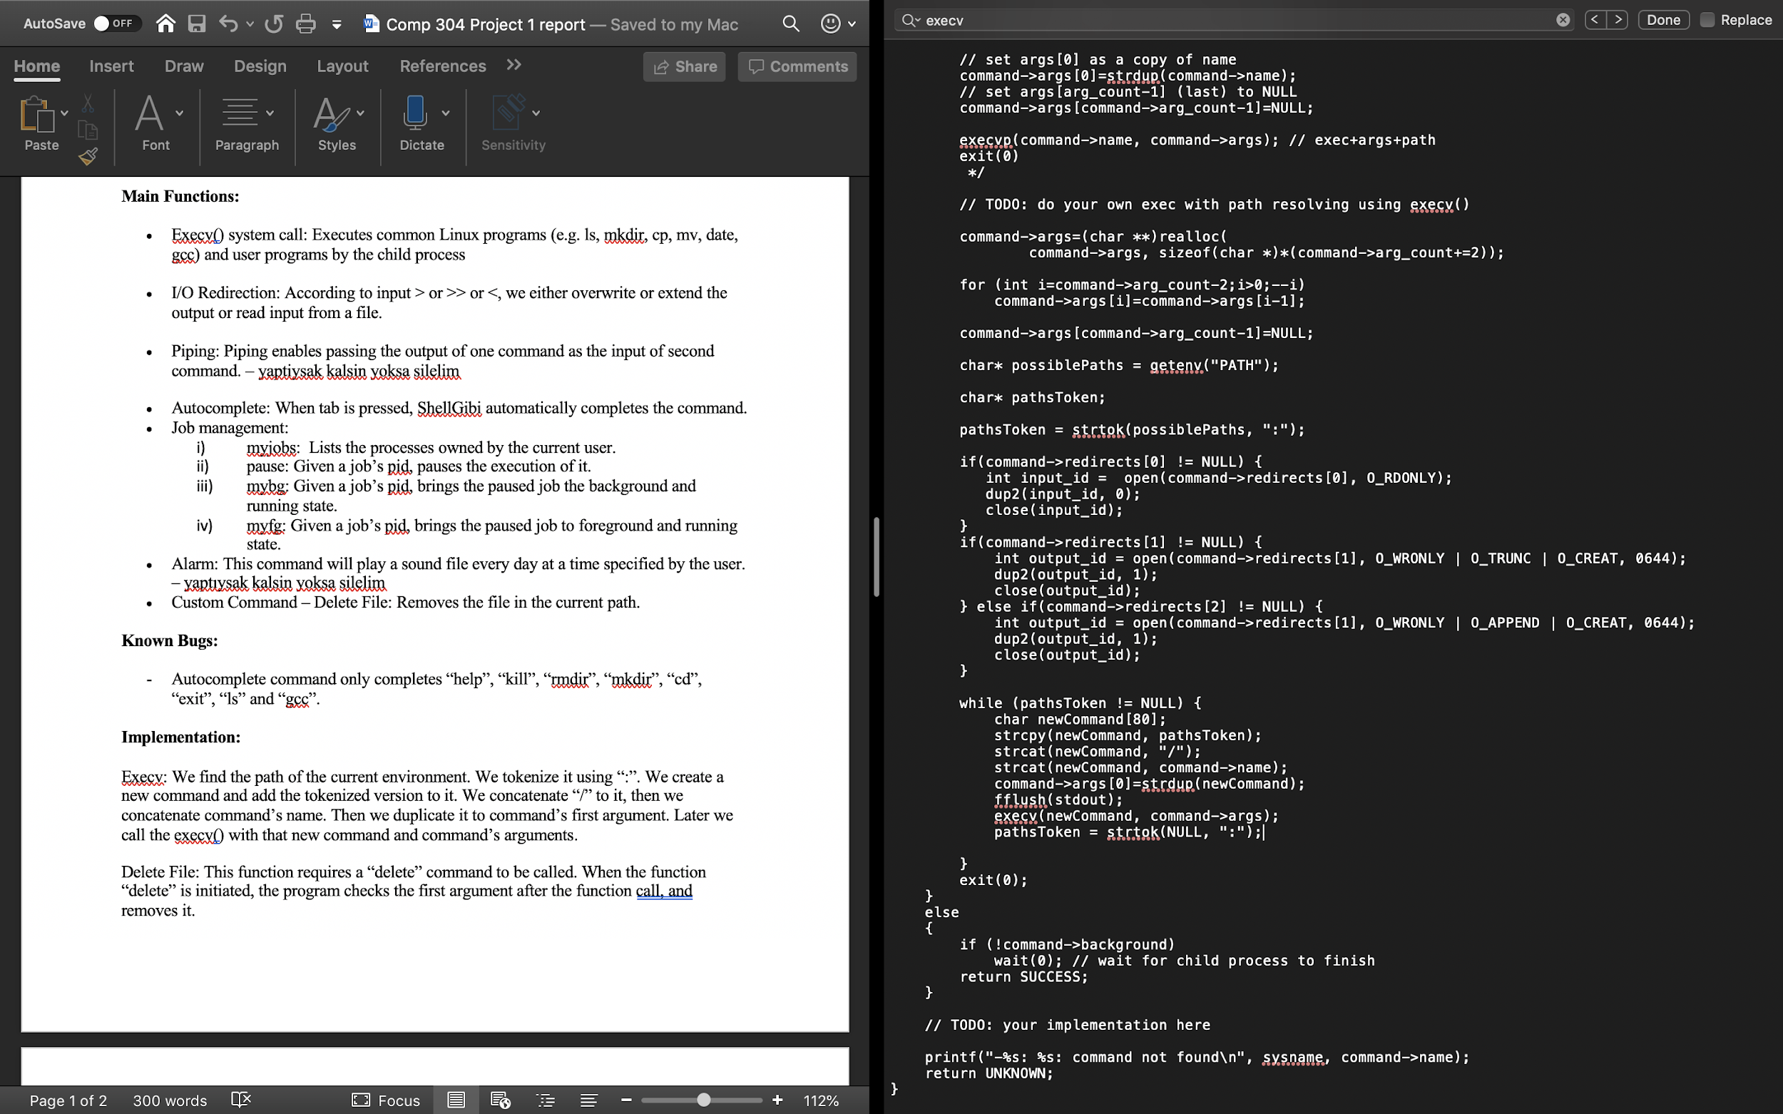

I/O Redirection: We handled the problem by using O_RDONLY, O_WRONLY, O_TRUNC, O_CREAT and O_APPEND.

Here is the screenshot:



Piping: We handled the problem by giving the stdout of the lastly executed command to the stdin of the next command. We do this until the command->next is NULL. We used dup2() call in this part. executeCommand() executes as same as execv().

Here is the screenshot:

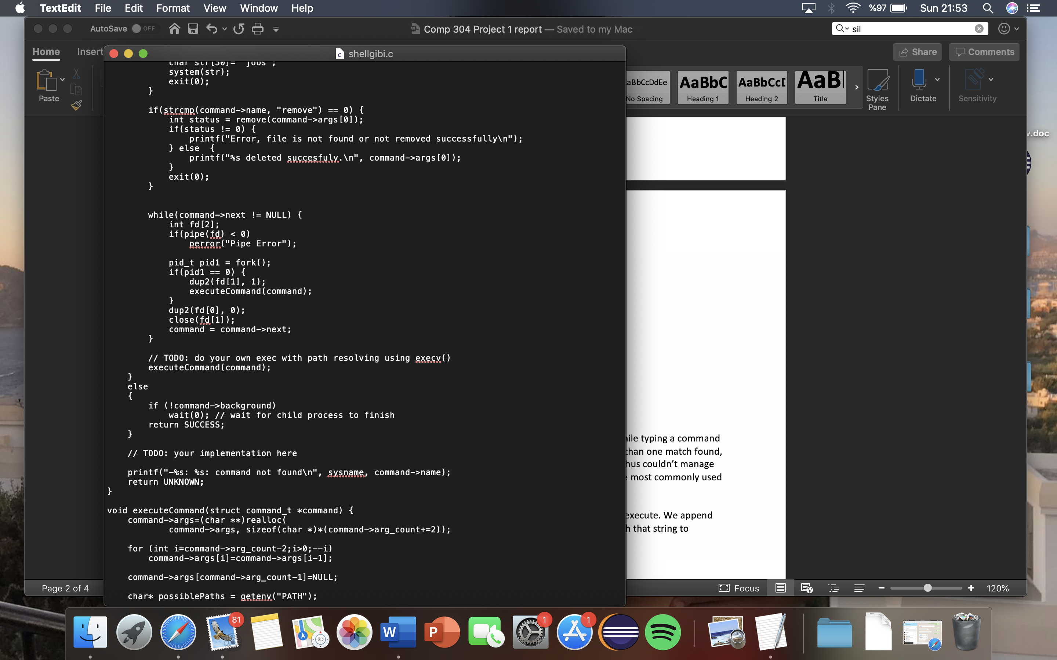

Autocomplete: We put every possible command into a string array. While typing a command if the Tab key is pressed, we searched in that array. If there are more than one match found,

it returned multiple values. However, we had a hard time doing that thus couldn’t manage to do it. So, our work is commented out and we hard coded it to some most commonly used commands.

Job Management: We created a string according to the which job we execute. We append the string with the pids if necessary. We call the system() function with that string to execute.

Here is the screenshot:

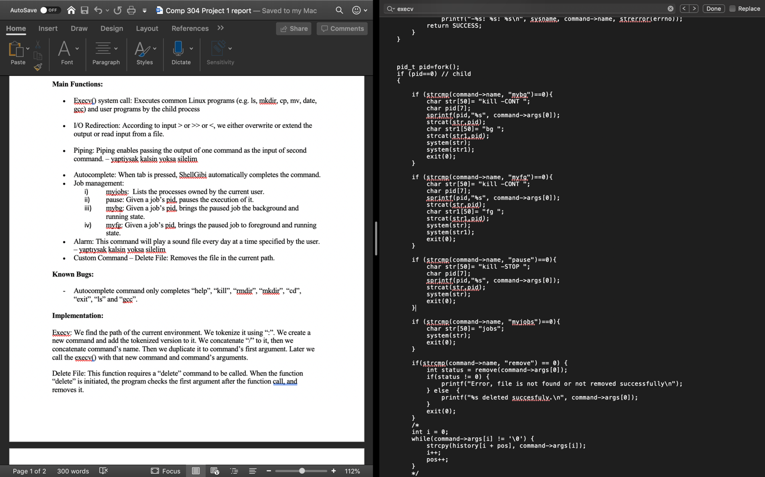.

Remove File: This function requires a “remove” command to be called. The program checks the first argument after the function call and removes it.

